Assignment 12.4

TASK_1:

Code:

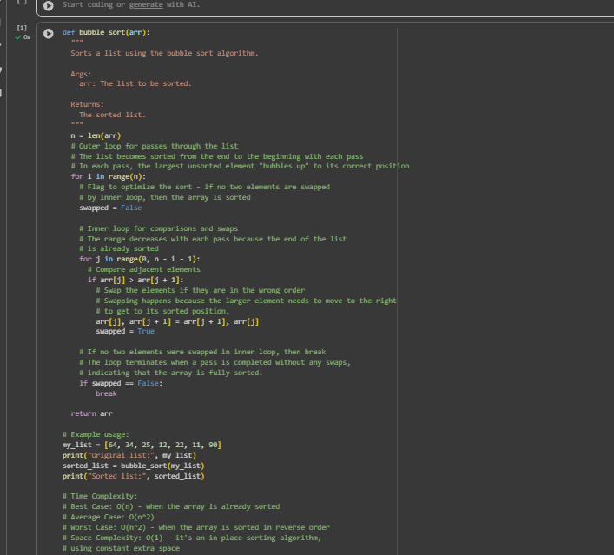

Output:

TASK_2:

Code:

Output:



Task-3:

Code:

Output:



TASK_4:

Code:

Output:



TASK _5:  
code:

Output:

*****